Greg Seda

CS 443 Assignment 2

**Question 1:**

Initial ERD

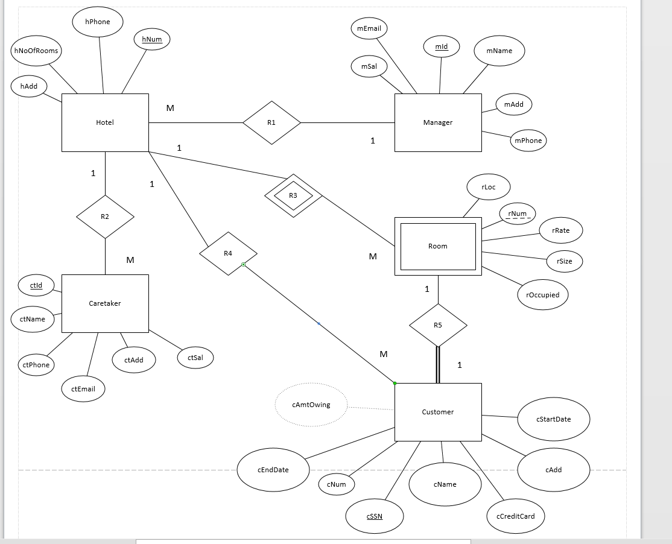

Initial Tables:

Hotel(hNum, hPhone, hNoOfRooms, hAdd)

Manager(mId, mEmail, mSal, mAdd, mPhone, mName)

Caretaker(ctId, ctName, ctPhone, ctEmail, ctAdd, ctSal)

Customer(cSSN, cName, cNum, cCreditCard, cAdd, cStartDate, cEndDate, cAmtOwing)

Room(rNum, hNum*, rLoc, rRate, rOccupied, rSize)

Finalized 3rd normal form tables:

Hotel(hNum, hPhone, hNoOfRooms, hAdd, mId*)

Manager(mId, mEmail, mSal, mAdd, mPhone, mName)

Caretaker(ctId, ctName, ctPhone, ctEmail, ctAdd, ctSal, hNum*)

Room(rNum, hNum*, rLoc, rRate, rOccupied, rSize)

Customer(cSSN, cNum, cName, cCreditCard, cAdd, cStartDate, cEndDate, hNum*, rNum*)

I was able to remove cAmtOwing because it was a derived dependency. It can be derived from the attributes: cStartDate, cEndDate and rRate.

(cEndDate - cStartDate) * rRate = cAmtOwing

     c)

Revised ERD

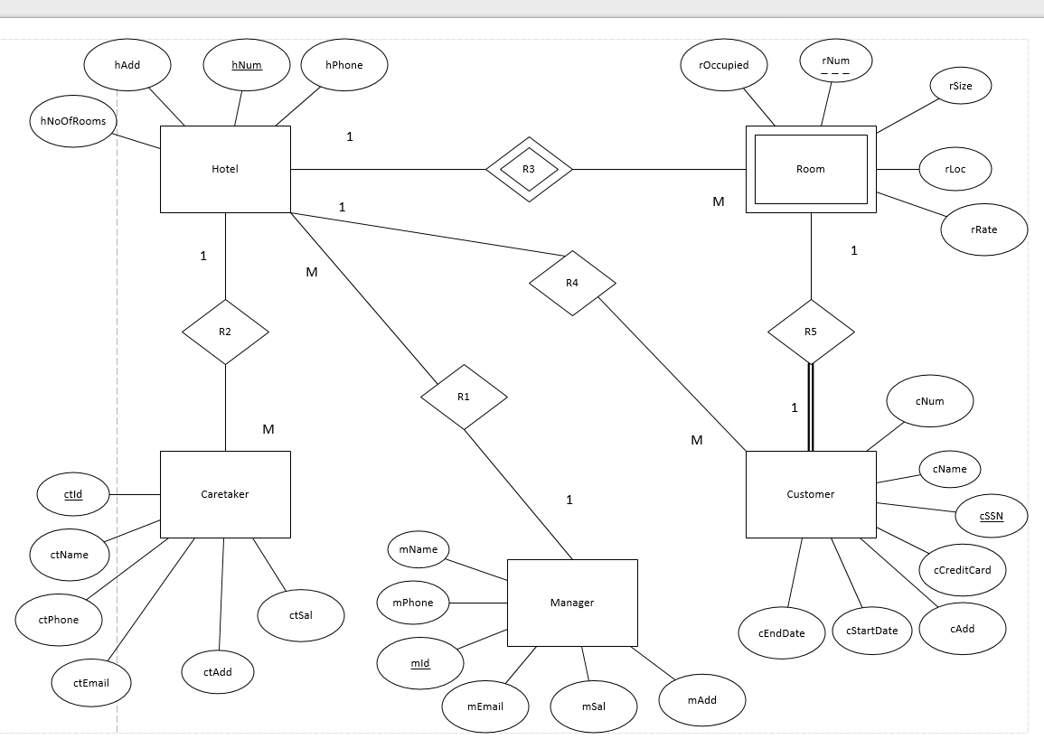

     d)

Here is the output. The code is on the txt file attached…..

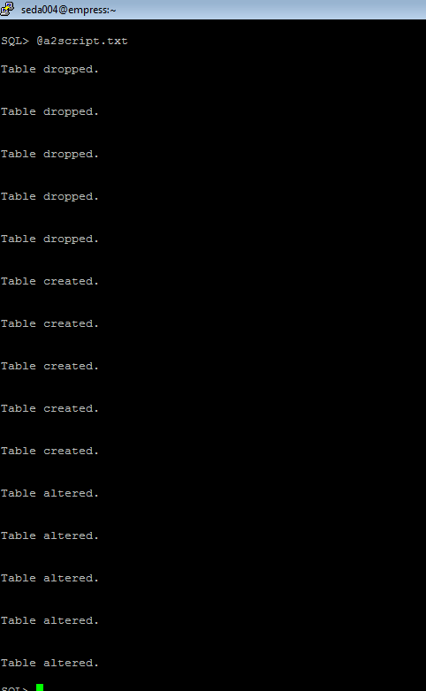

**Question 2:**

1. Write a select statement to list all the columns from the Offices table.  'Select *'  is not allowed.  Return the list in Office order.

SELECT Office, City, Region, Mgr, Target, Sales

FROM Offices

ORDER BY office ASC;

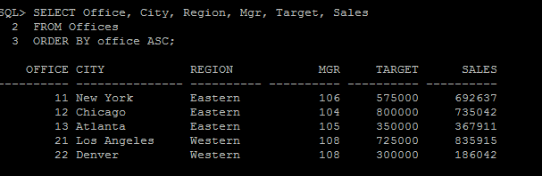

2) List the Product Name (its description), and dollar value of quantity on hand (price * quantity) .  Return the list in descending order by value.

SELECT Description, (Price * Qty_On_Hand) AS Dollar_Amount

FROM Products

ORDER BY Dollar_Amount DESC;

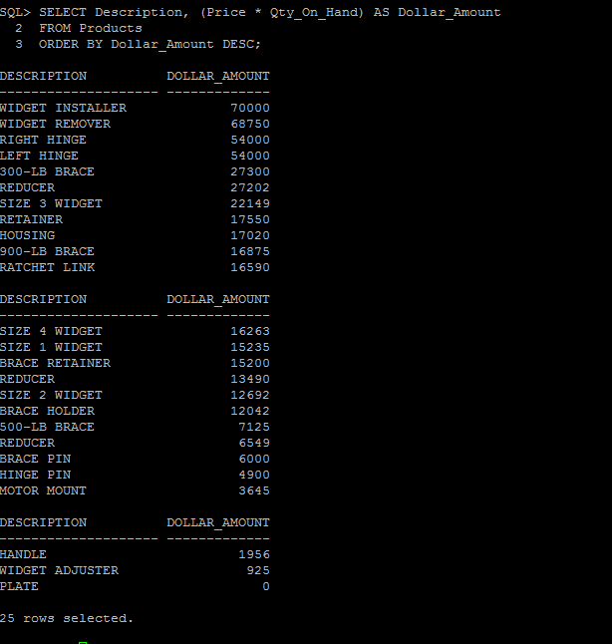

3) New: List the Order Number, Order Date, Customer Number and Sales Rep Number for orders for part 'XK47' or '775C'. (Use a compound search condition - OR.)

SELECT ORDER_NUM, ORDER_DATE, Cust, Rep

FROM Orders

WHERE (Product = ‘XK47’ OR Product = ‘775C’);

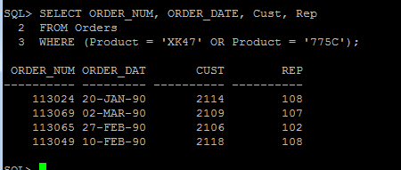

4) List the Name and Age for all Sales Reps in the following offices: 12; 21; 13.  (Use the set membership test - IN.)

SELECT name, age

FROM Salesreps

WHERE rep_office IN(12, 21, 13);

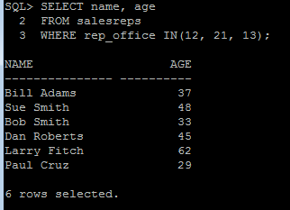

5) List the names of all Sales Reps who have the letter 'o' (this is lower case o) as the second character of their name.

SELECT name

FROM salesreps

WHERE name LIKE ‘_o%’;

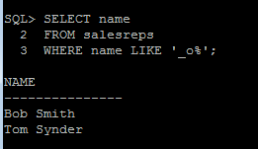

6) Return the Sales Rep ID and Name of any Sales Rep not assigned to an office yet.

SELECT EMPL_Num, name

FROM salesreps

WHERE REP_OFFICE IS NULL;

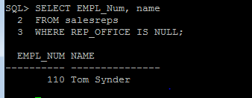

7) Show all the sales rep names with last name “Smith”.

SELECT name

FROM salesreps

WHERE name LIKE (‘%Smith’);

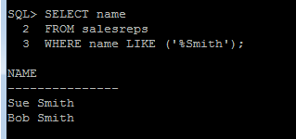

8) List different titles in the sales reps table. Only list each title once and unknown titles should be ignored.

SELECT DISTINCT title

FROM salesreps

WHERE title is NOT NULL;

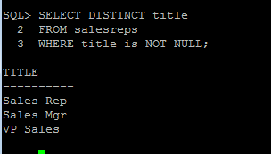

9) List the description of the products which are at least 6 character and less than 10 character long. No duplicate row is allowed. You can use the build in function  length() to do this. For example, length(name) return the number of characters for attribute called “name”.

SELECT DISTINCT description

FROM products

WHERE length(description) >= 6 AND length(description) < 10;

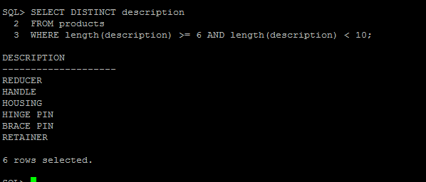

10)   List the the order nums with the name of the rep who placed the order and the name of the customer who made the order and the name of the rep for that customer

SELECT DISTINCT orders.order_num, salesreps.name AS “Salesrep_Name”, customers.company, S1.name AS “Customer_Name”

FROM orders, salesreps, customers, salesreps S1

WHERE rep = salesreps.empl_num

AND customers.cust_num = orders.cust

AND customers.cust_rep = S1.empl_num;

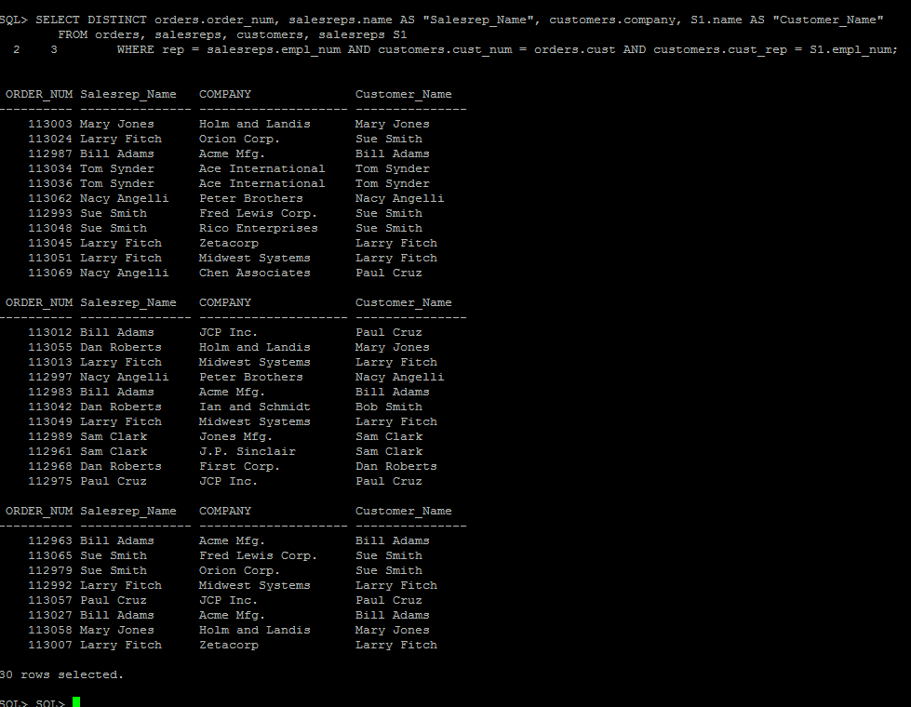

**Question 3:**

1) List the Mfr Id, the Product Id, Company and PRICE of all products brought by customers where customer number is one of (2112,2105,2119) and where the amount of the order < $5000.00.  Order the results by ascending Company.

SELECT DISTINCT MFR_ID, PRODUCT_ID, COMPANY, price

FROM products, customers, orders

WHERE orders.cust = customers.cust_num AND customers.cust_num IN (2112, 2105, 2119)

AND AMOUNT < 5000 AND orders.MFR = products.MFR_ID AND orders.product = products.PRODUCT_ID

ORDER BY company ASC;

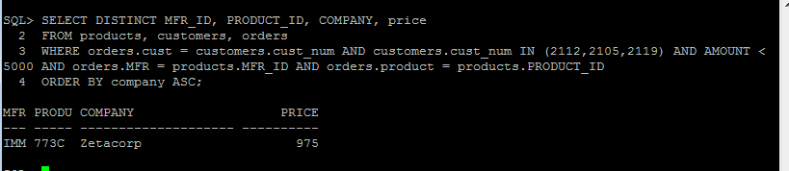

2) List all salesreps (id and names) and all orders (orderNumber) in which the salesrep is the company’s (i.e. the customer) rep (Cust Rep), but didn’t take the order. Order the result based on name in ascending order.

SELECT DISTINCT Salesreps.Empl_Num, salesreps.name, order_num

FROM salesreps, orders, customers

WHERE salesreps.empl_num = customers.cust_rep

AND orders.rep != salesreps.empl_num

AND orders.cust = customers.cust_num

ORDER BY salesreps.name ASC;

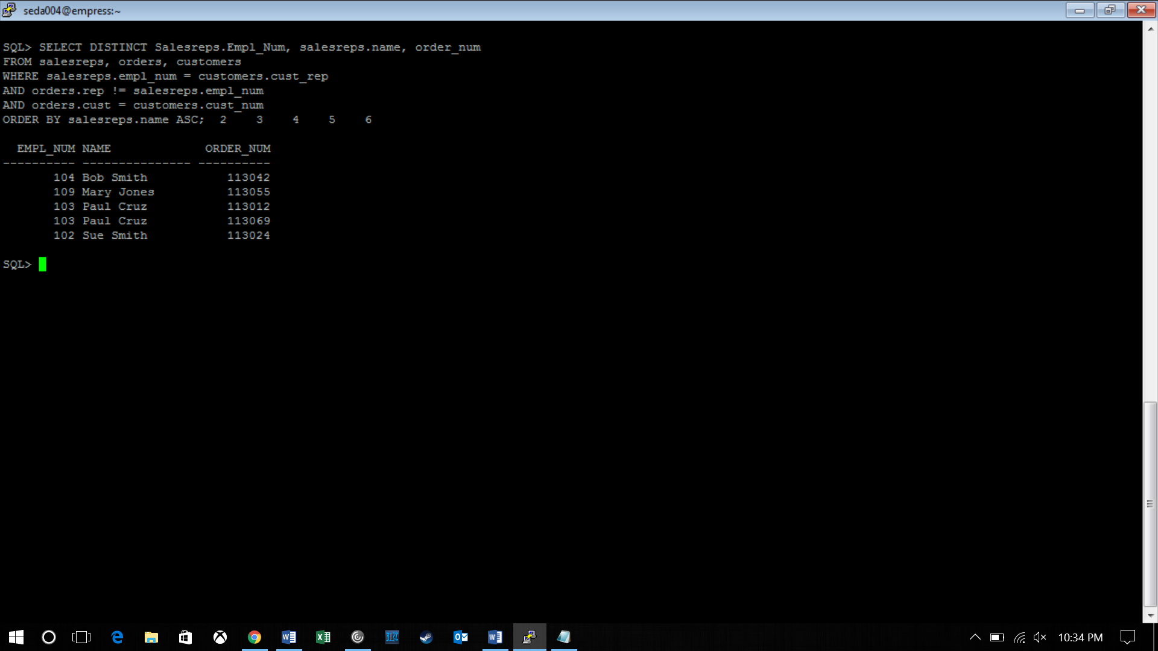

3) List all customers (Customer number, Company, and Credit Limit) and orders (Order Number, Amount) where the order is within $10000.00 of the Credit Limit (less than or equal to $10000). Sort the result by Customer number in descending order.

SELECT DISTINCT customers.cust_num, customers.company, customers.credit_limit, orders.order_num, orders.amount

FROM orders, customers

WHERE ((customers.credit_limit - orders.amount) <= 10000)

AND orders.cust = customers.cust_num

ORDER BY customers.cust_num DESC;

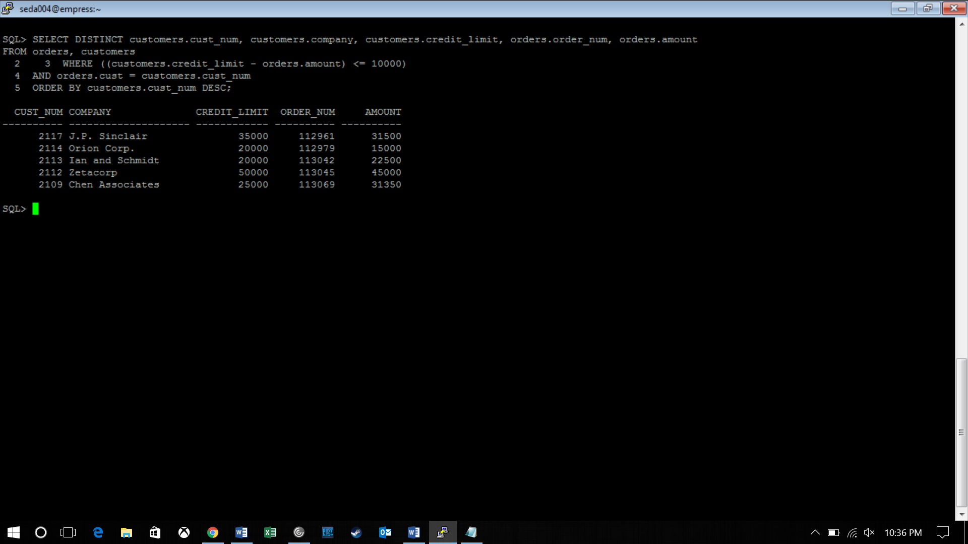

4) List all salesreps names and their managers’ names where the salesrep is at least as old as the manager.

SELECT DISTINCT S1.name AS “Employees”, S2.name AS “Managers”

FROM salesreps S1, salesreps S2

WHERE S1.manager = S2.empl_num AND S1.age >= S2.age;

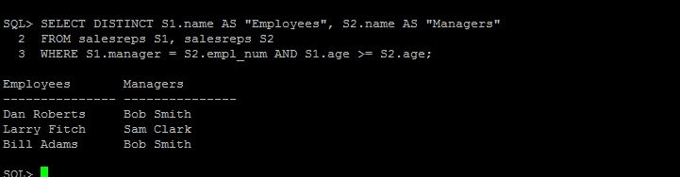

5) List all salesreps (Name) and the City they work in where the sales of the salesrep < Quota and the sales for the office is < Target.

SELECT salesreps.name, offices.city

FROM offices, salesreps

WHERE salesreps.rep_office = offices.office AND (salesreps.sales < salesreps.quota)

AND offices.sales < offices.target;

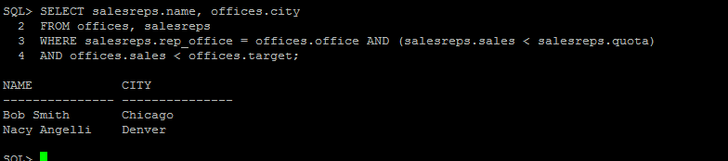

6) List the name, id, and hire date of the salesreps where at least one of the two conditions hold:

·   The salesrep sales should be greater than the quota

·   The salesrep has taken an order from Customer number 2117, 2111, or 2101.

Sort the result by the salesrep’s id.

SELECT DISTINCT salesreps.name, salesreps.empl_num, salesreps.hire_date

FROM salesreps, orders

WHERE ((salesreps.sales > salesreps.QUOTA)

OR (orders.rep = salesreps.empl_num

AND orders.cust IN (2117, 2111, 2101)))

ORDER BY salesreps.empl_num;

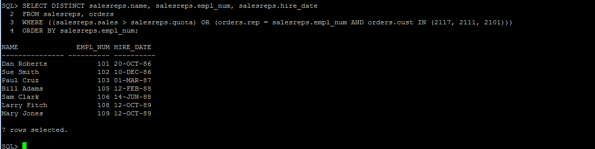

7) List all orders (Order Number) over $25000 showing the company placing the order, the Customer Rep assign to the company, the Office id and the city where the Customer Rep works in, such that the Customer Rep’s manager is not the person who actually took the order.

SELECT DISTINCT orders.order_num, customers.company, customers.cust_rep, salesreps.rep_office, offices.city

FROM orders, customers, salesreps, offices

WHERE (orders.AMOUNT > 25000)

AND offices.office = salesreps.rep_office

AND ((customers.cust_rep = salesreps.empl_num)

AND (salesreps.manager != orders.rep))

AND (orders.cust = customers.cust_num);

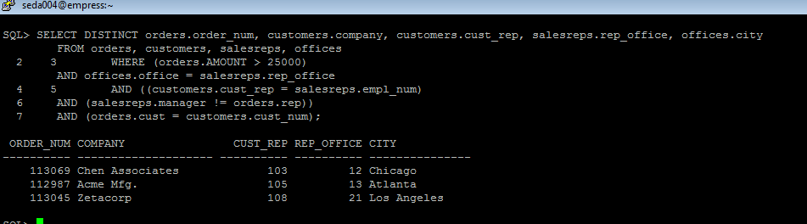

8) List all customer reps (their name and their id) and their managers name in which the manager has taken an order for the customer Rep’s company or the manager is based in New York or Denver. Use appropriate column header

SELECT DISTINCT e.empl_num, e.name AS "Employee_Name", m.name AS "Manager_Name"

FROM customers, orders, offices, salesreps e, salesreps m

WHERE e.manager = m.empl_num

AND m.empl_num = offices.mgr

AND orders.rep = m.empl_num

AND offices.city IN ('New York', 'Denver');

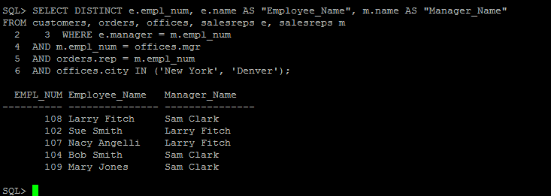

9) List all products (ProductId, and Description), customers (CustNum, Company) who have bought that product, and orders (Order Number, and Order Date) where the order < $1000.  Sort the rows by the OrderDate.

SELECT DISTINCT product_id, description, cust_num, company, order_num, order_date

FROM products, customers, orders

WHERE (AMOUNT < 1000)

AND (cust = cust_num)

AND (product = product_ID)

AND (MFR = MFR_ID)

ORDER BY Order_Date;

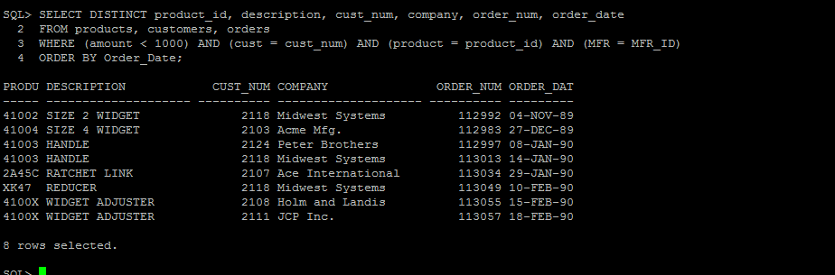

10)   List the name of the salesreps and the name of their managers only if the manager has taken care of some orders.

SELECT DISTINCT salesreps.name AS “Salesreps_Name”, S1.name AS “Managers_Name”

FROM salesreps, salesreps S1, orders

WHERE (salesreps.manager = S1.empl_num) AND (orders.rep = S1.empl_num);

